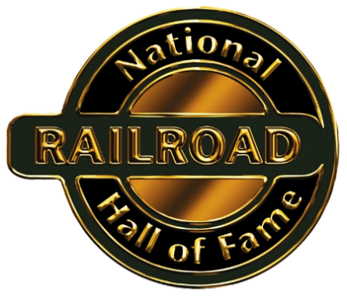
Job Description
Communications Director
Summary:
The Director helps develop and implement marketing and communications strategies and initiatives. This full-time position reports to the Executive Director. Some evening and weekend work and overnight travel is necessary for special events. A four-year college degree is required; graduate degree preferred.
Skills:
The Director has excellent written and verbal communication skills, is creative and artistic, and has strong graphic design abilities.
The position requires superior organizational and planning skills, a strong work ethic, and ability to coordinate multiple projects and events. The Director interacts well with the public and as a team member in our intimate office setting.
The Director is accomplished with Microsoft Office Suite; has a solid working knowledge of Wix, Constant Contact, and Canva; and is adept with social media platforms. Videography skills are a plus.
Duties:
The Director supports the organization’s programming and development initiatives through comprehensive marketing, communications, branding, and public relations strategies. They connect effectively with a broad range of constituent groups through a variety of written, graphic, and on-line communication materials.
The Director manages content and design of print and online materials including donor communications, promotional and tradeshow materials, social media content, media relations, and e-mail marketing. The Director maintains the organization’s website to ensure a robust online presence.
The Director anticipates organizational needs and executes projects to comfortably meet deadlines. They budget, monitor, and report project expenses. They work with print vendors to establish quotes, production schedules, and timely delivery of materials.
The Director helps execute major events and programming, including annual induction ceremonies, Railroad Days and Galesburg Express activities, and private railroad car conventions. They act as an organizational representative and liaison as required.
Compensation:
$32,000 to $37,000; flexible leave policy; hybrid WFH scheduling available
To Apply:
Send cover letter, resume, and references to:
National Railroad Hall of Fame
Attn: Julie King, Executive Director
64 South Prairie Street, Suite 216
Galesburg, Illinois 614o1

